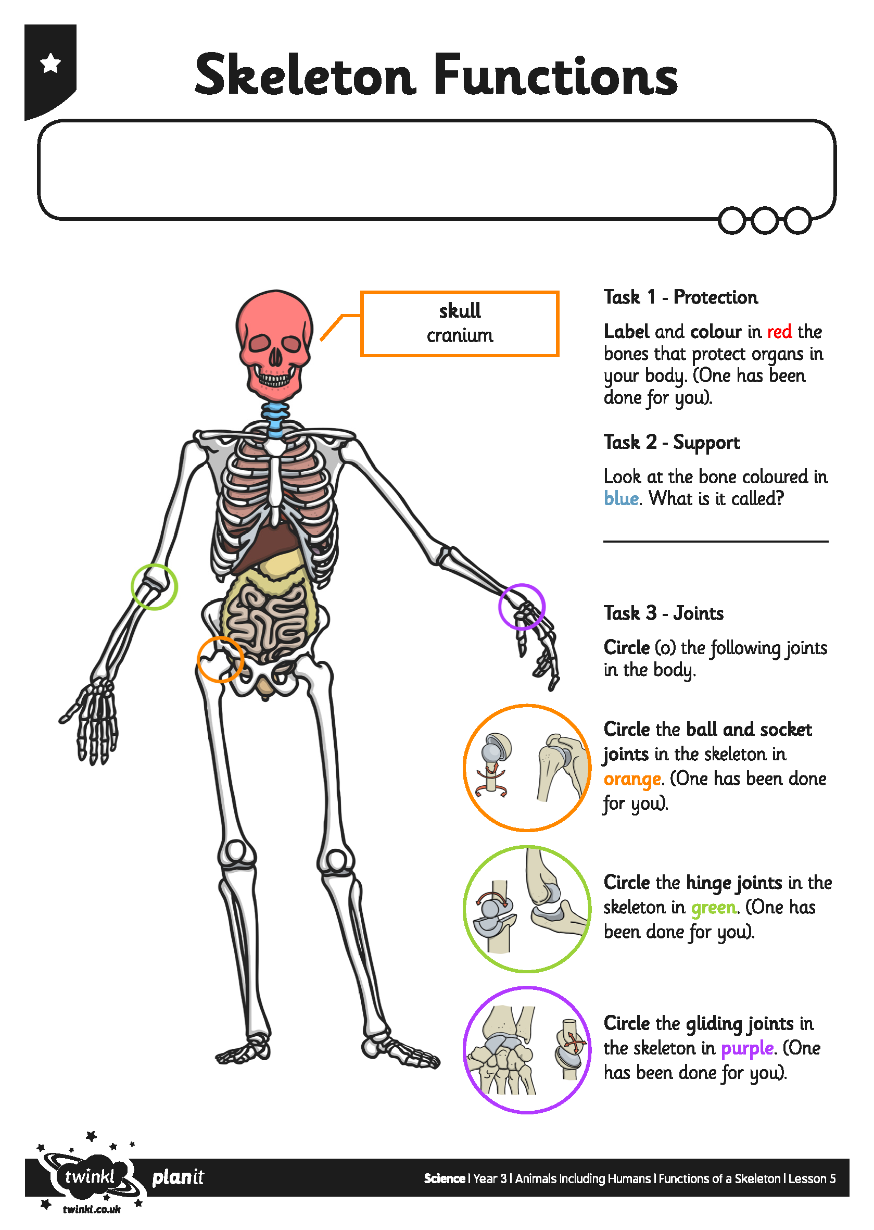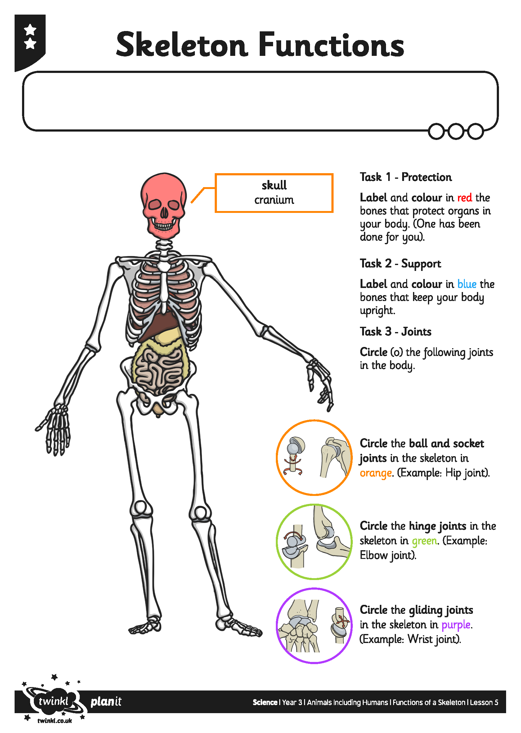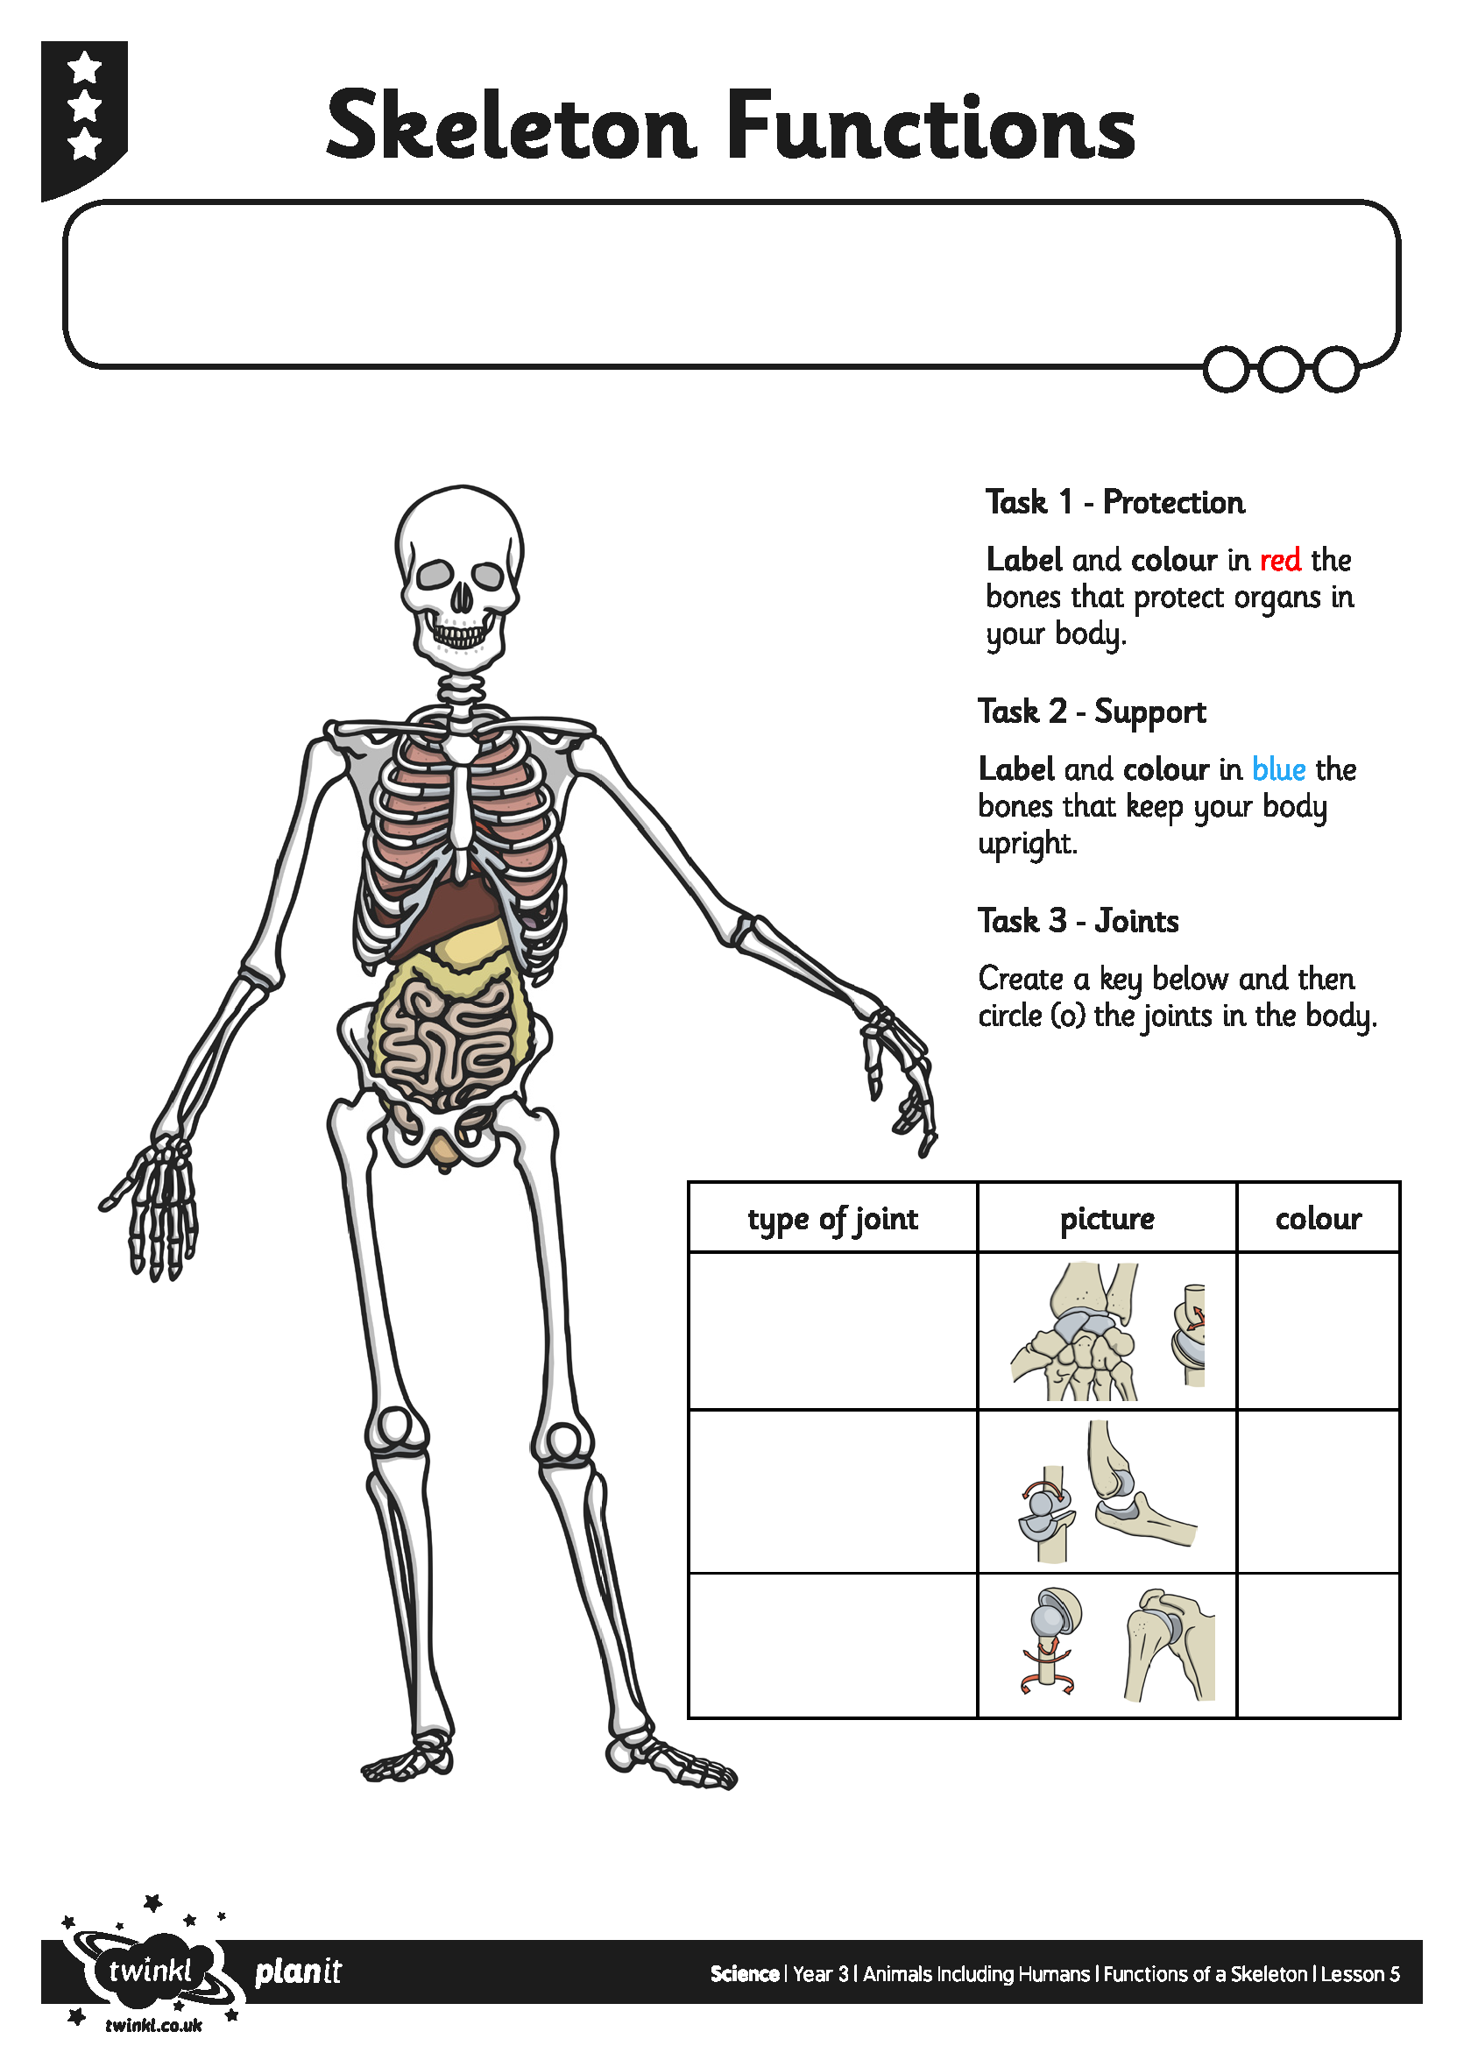
I can explain the functions of a skeleton.
I can explain the functions of a skeleton.

I can explain the functions of a skeleton.

