Art and Design Challenge Task Sheet
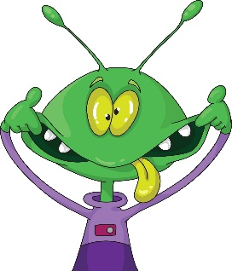  Imagine that an alien visits you on Earth. Draw the alien from your imagination. You could use a variety of medium to make your drawing even more interesting.  Double challenge: Can you draw your alien so it is as tall and as big as yourself? | 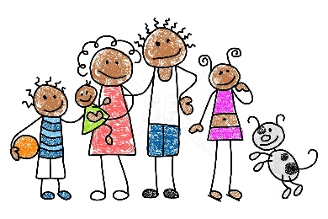  Draw each member of your family using a different medium. You could use coloured pencil for one person, and then crayons for another.  Double challenge: Can you create sculptures of your family members? | 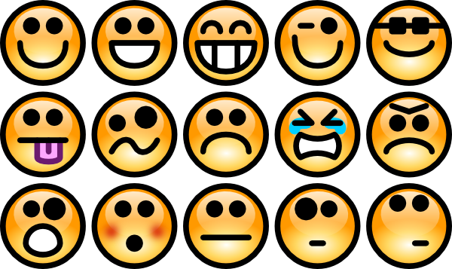  Write a list of different emotions. For example, happy, sad, angry. Then draw what these emotions might look like. Think about your colour choices and what kind of marks you might make on the paper. The emotion ‘angry’ makes me think of the colours red and black and large zig zag lines.  Double challenge: Can you recreate one of your drawings on a larger scale using household items. E.g. you might use socks, or the tie from a dressing gown for the lines on your drawing.
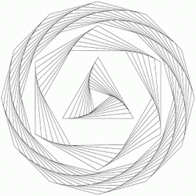  Draw a picture using only straight lines (with a ruler) or curvy lines. You decide what to draw and what medium to use.  Double challenge: Can you draw your picture on a piece of paper that is the same size as a stamp? | 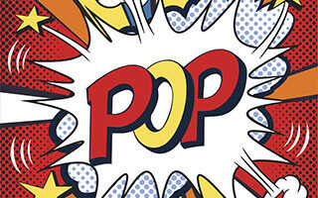  Roy Lichtenstein is a famous artist who creates art using Ben Day Dots. Using your name, can you create a piece of pop art similar to that of Lichtenstein?  Watch the video below to find out how to get started. Be bold!  https://www.youtube.com/watch?v=jS-OTAwPRDY  Double challenge: Think of your own word that you would like to turn into a piece of Pop Art! | 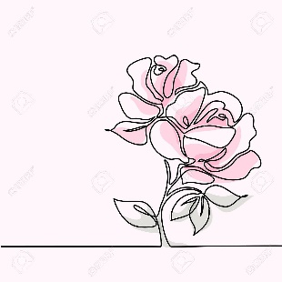  Draw a picture without taking your pencil off once! This is called continuous drawing. You don’t just have to use a pencil, you could also use a crayon, felt tip etc. To begin with you could choose something simple to draw like a flower.  Double challenge: Could you use this technique to create a piece of outdoor art using chalk?

