Art and Design Task Sheet
Using the fact sheet about Andy Goldsworthy design a brochure for an exhibition that he might create and show to the public. Look at the images of his art work and think about how you might describe them using relevant adjectives. What might you name the pieces?  Below is a list of things that you could include in your brochure:  1. An introductory paragraph about the artist  2. Images/drawings of the work to be exhibited  3. Subheadings in bold text  4. A map of the gallery  5. A list of the materials used to create the art work  6. A pricing list  7. Dates of when the pieces of art were created.  Don’t forget to include some of your own ideas. You might want to have a look on the internet and see if you can find out anything else about Andy Goldsworthy and his artwork.  Challenge: Can you make your brochure A3 size and fill both sides? | Draw a portrait using your sketching skills. You could draw yourself, or a family member. Remember a portrait only includes your face. Once you have drawn your portrait you are going to use that to create a ‘muddy face’  You will need:  Mud  Trees  Natural found items, e.g. twigs, stones, grass, flowers  Water  What you need to do:  1. Mix the mud with some water to make it more pliable.  2. Add the mud to a tree trunk and begin to design and sculpt your face.  3. You could use sticks to add texture to the sculpture.  4. Add your collected items to create your face.  5. Have fun!  Challenge: Can you create a mud sculpture in the style of Picasso? It might be more abstract! | 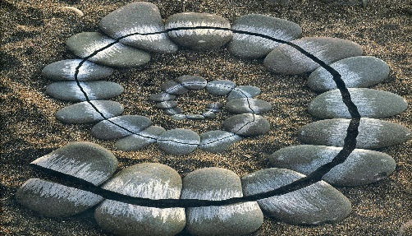  Use natural items to create a land art sculpture outside on grass or a paved area. Think about pattern and colour and using a range of materials to make your art more interesting. Magpie Andy Goldsworthy’s artwork as a starting point. When looking at examples of his artwork, think about what you like or find interesting, and materials that have been used to create the art work.  Top tips:  1. Flour paste can be used to glue the lighter materials to the floor if it is windy. (This is glue made from  flour and water and will wash away without causing any damage)  2. Add fresh flowers to make your design colourful.  3. Collect more materials than you think you will need-your idea may change!  Challenge: Can you make your land art as big as yourself?
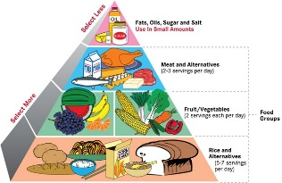  As the hot sunny weather approaches we would like you to think about planning a healthy picnic. Remember a healthy diet should include a wide variety of nutritious foods for sufficient intake of all nutrients, including vitamins and minerals. Foods to include are breads, pastas, lean meats, fish, fruits and vegetables.  Next design your own healthy picnic using annotated sketches to explain your ideas. Finally make and eat your healthy picnic outside. Bon Appetite!  Challenge: Can you make a sandwich 120mmx120mm? | Can you complete all of these challenges in one day?  1. Hang something from a tree.  2. Tie two sticks together using only natural materials.  3. Balance one natural object on top of another in an unusual way.  4. Wedge something between two trees that will stay there on its own.  5. Make an arch or a tunnel from natural materials.  6. Find a natural piece of material that looks like something else. E.g. a face.  7. Make a pattern with stones.  8. Make a shape from leaves.  9. Make a spiral using natural materials.  10. Find out how many stones you can balance on top of each other. | 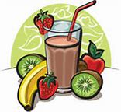  Imagine you are a culinary whizz in the kitchen. Create the ultimate smoothie by following a recipe that you have found either in a book or on the internet. Write your recipe and take a photograph of your smoothie.  Challenge: What do you have in your kitchen that you could add to your smoothie to make it one-of-a-kind?

