Outdoor Learning-Step into summer 2

Hug a Tree  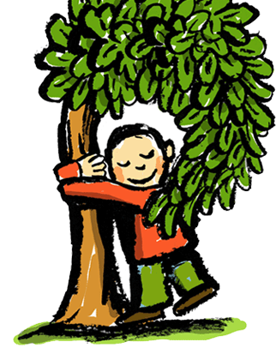  Get up close and personal with a tree. Allow a family member to blindfold you and guide you towards a tree. Feel its bark-how does it feel? Rough? Smooth? Allow yourself to be guided back to the start, then remove your blindfold and see if you can find your tree, just by using your sense of touch. Now test your family member.  Challenge: Can you use a thesaurus to up-level your adjectives? Draw your tree and write the adjectives around the picture? | Tree Planting Campaign  Around the world there are lots of areas where deforestation is out of control, ruining the environment and endangering the animals and insects that live there. Think about your local area and start a letter-writing campaign to have more trees planted in your area. Persuade people by explaining the need for and uses of trees. To help you start, have a look online or in books at people’s arguments for not cutting down trees.  Challenge: Can you create a colourful and interesting poster explaining the dangers of deforestation? | Journey Map  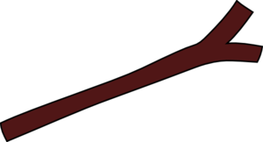  Use a journey stick to record a walk in a ‘wilderness’ near you. Record your walk by collecting fallen treasure and attaching it to a stick. Alternatively, you could include photographs to create a picture map of your walk.  Challenge: Can you create a map using coordinates to pin point fallen objects of places?
Perfumed Potion  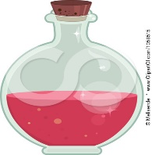  Many herbs and flowers have scents that attract the insects that help it to pollinate. Conduct a scent search of your outdoor area. Crush herbs and flowers to investigate smells and mix them together to create a ‘perfume’. You could create a list of ingredients for a potion that would heal a broken heart, stop a storm or cure a headache.  Challenge: Can you create a set of instructions that describe how to make your potion? Don’t forget to include the list of ingredients! | Mystical Music  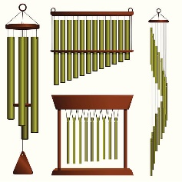  Make a musical instrument or wind chime from the objects you can find outside. You could look in your garden or your local area to source the items that you might need.  Challenge: Can you write a set of instructions that describe how to make a musical instrument/wind chime out of natural items? | Survival Shelter  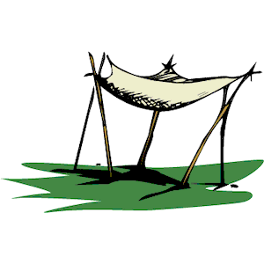  Imagine you are lost in the wilderness and need to build a shelter to protect you from a gathering storm. Use tarpaulins or another waterproof material, rope or sticks and branches to create a shelter. Can you make it waterproof to weather a storm? Test your shelter with a watering can. If you don’t have much material, you could make this for a teddy or toy.  Challenge: Can you draw and label your shelter?  Extra challenge: Can you measure and cut your materials using cm?

