Ely St. John’s Primary School
Weekly Learning – Year 3
WB 8th June
Maths

This week you will need to access the White Rose Hub website to find your maths lessons.

Go to: https://whiterosemaths.com/homelearning/year-3/

You will need to use the Summer Term Week 7 lessons.

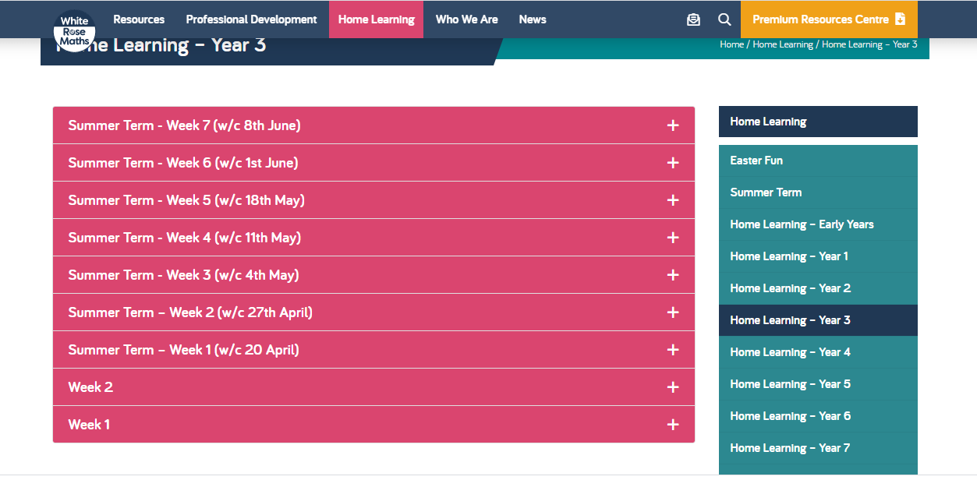

Watch the video lesson and complete the sheets for each lesson. You can use the answer sheet to check your answers once you are finished.

Lesson 1 – Equivalent fractions (1)
Lesson 2 – Equivalent fractions (2)
Lesson 3 – Equivalent fractions (3)
Lesson 4 – Compare fractions
Lesson 5- Maths challenge

ADULTS PLEASE NOTE:
The White Rose videos make reference to the BBC Bitesize resources. You can access those here if you would like some extra support or materials to use with your child.

https://www.bbc.co.uk/bitesize/tags/zmyxxyc/year-3-and-p4-lessons/1

