Art and Design Task Sheet-Summer 2
Complete an observational drawing of a flower. Use your sketching skills to help you. Look carefully at the flower in detail and draw everything that you can see. The more you look at the flower, the more detailed your drawing will be. Remember to fill your page. A good idea is to draw 4 dots on the page showing where the drawing will reach to and from when finished. Before you start this task, complete the ‘shading circles activity sheet’  Challenge: Can you choose one section of a flower and draw that section only? To help you, cut out a square shape on a separate piece of paper. Lay the piece of paper on the flower and move it around until you are happy with what you can see in the square. Remember to only draw what you can see. | 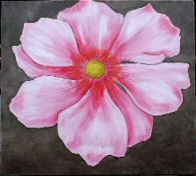  Complete an observational drawing of a flower in coloured pencil, paint or oil pastel. Look carefully at the flower in detail and draw everything that you can see. The more you look at the flower, the more detailed your drawing will be. Start your drawing in the middle of your page and work outwards. Remember to fill your page. Look at the Henri Rousseau pictures and think about how Rousseau showed the same basic colours (greens) in different ways by blending with other colours e.g. yellow, brown…  Challenge: Can you replicate one of Henri Rousseau’s pieces of art? | 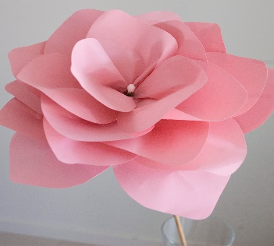  Make a paper flower using a piece of card. Click on the link below and watch the video to help you get started.  https://www.bing.com/videos/search?q=how+to+make+a+paper+flower&&view=detail&mid=01F7F0BD4D29DACE32AA01F7F0BD4D29DACE32AA&&FORM=VDRVRV  Challenge: Can you make a bunch of flowers in different sizes?
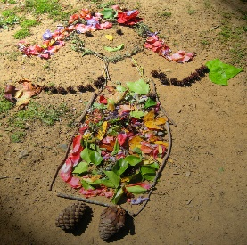  Why draw with crayons when you can get creative with natural items. Create a picture using natural items. Collect petals, leaves, bark, sticks etc. You could either create your masterpiece in your back garden or stick the items to paper. You decide!  Challenge: Can you create a piece of art as big as yourself? | 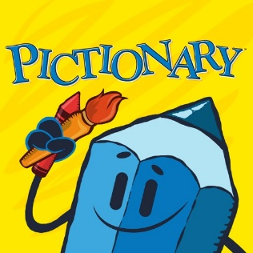  Test your artistic skills by playing the Pictionary Game. Read the ‘Pictionary Sheet’ and with your family test each other. Make the game even more challenging by setting a time limit. | 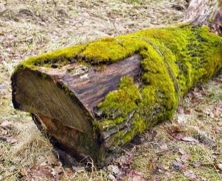  As the weather gets warmer, you will begin to notice lots of minibeasts appearing in your garden and local area. To keep these creatures’ safe and content you are going to design and make a bug hotel for them. Read through the presentation and watch the videos to help you get started.  Challenge: Can you design a habitat for one of your teachers? Think about their likes and dislikes, what would make them feel safe and what they might like to eat.

