**HEDGEHOG**

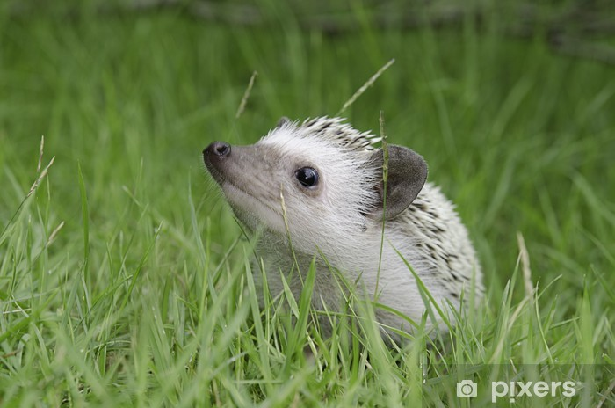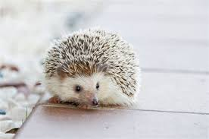By Jessica Smith

**Tiny-toes**

**Ouchy-prickles**

**People-scared**

**Sleep-lover**

**Hidden-home**

**Millipede-muncher**

