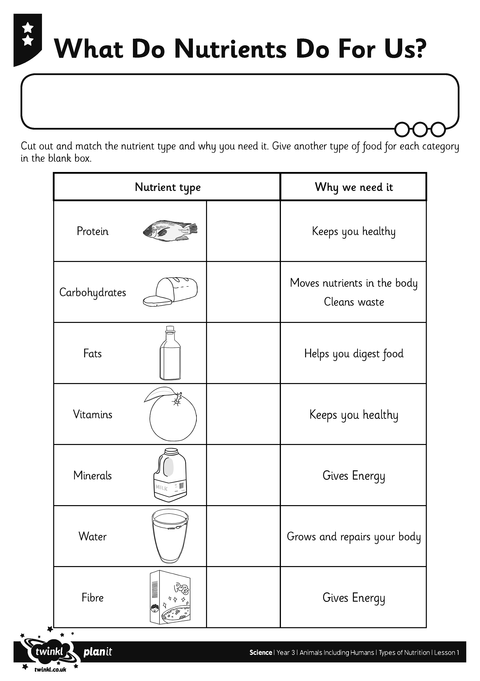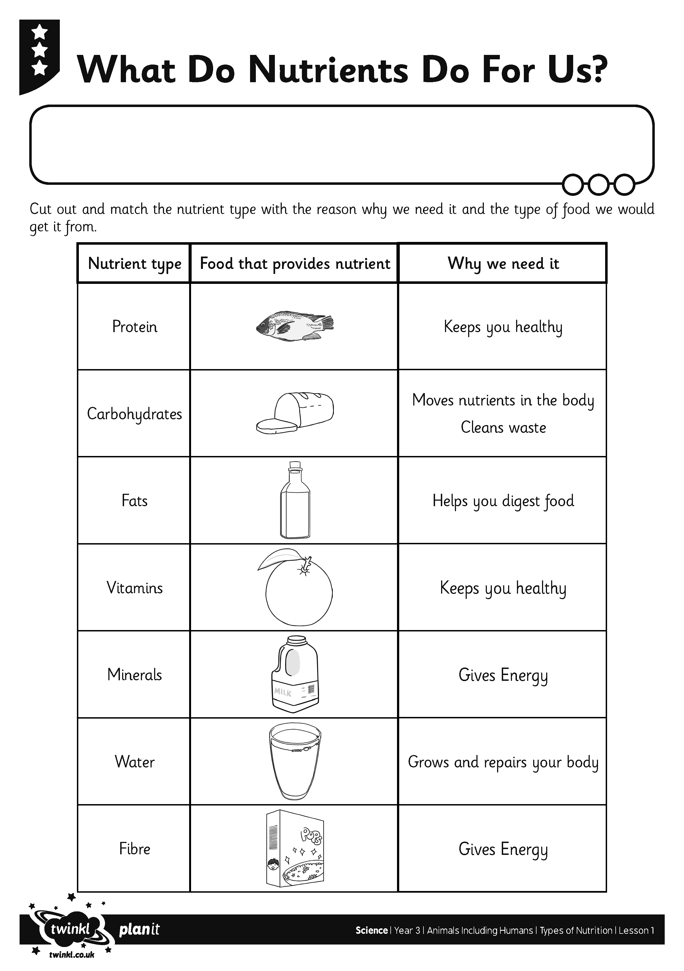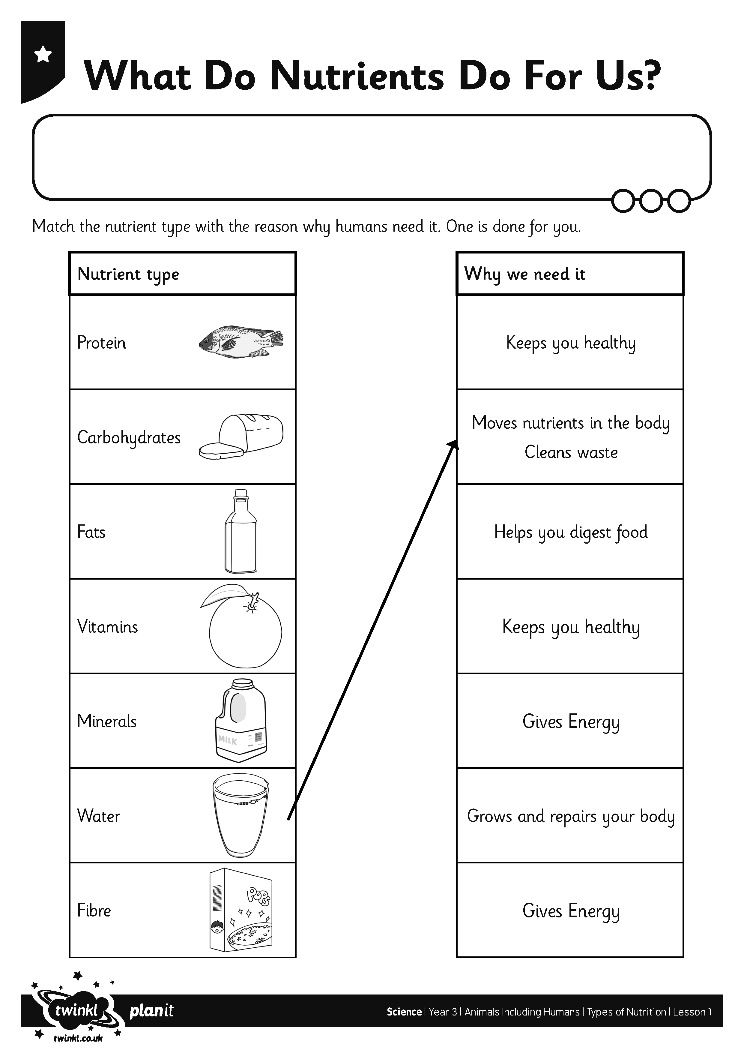
I can explain why living things need the right type of nutrients.

I can explain why living things need the right type of nutrients.

I can explain why living things need the right type of nutrients.

