Ely St John’s
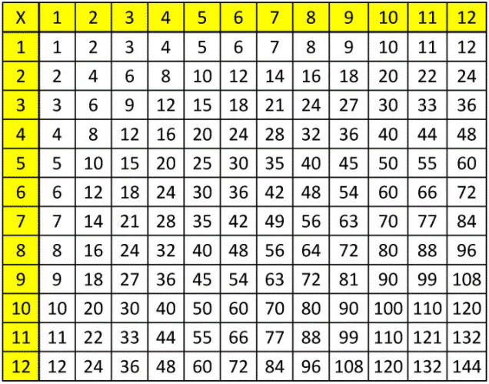
Parents’ Guide to Times Tables

Help your child to achieve their best in mathematics.

The importance of times tables knowledge

• A fluent recall of times tables facts is crucially important for your child’s progression in mathematics.
• Without a deep understanding of multiplication and division facts, children frequently struggle with problem solving, fractions and measurement.
• Many mental maths activities and tests require a quick recall of multiplication and division facts.
• ‘Knowing’ times tables means a child will be able to recall any of the multiples of a times table out of order within 3 seconds, as well as knowing the matching division facts i.e. 4 x 6 = 24 24 ÷ 6 = 4.
• Learning multiplication facts is most effective when there is collaboration with school, parents and children. In school we regularly spend time learning times tables, but a child will be much more successful if they practise outside school independently and alongside parents.

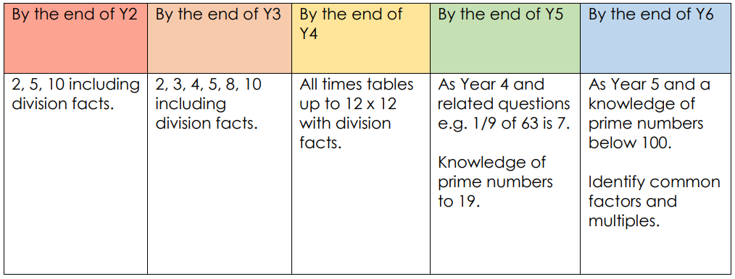
National Curriculum times tables expectations

Regular Revision
The key to learning times tables is frequent repetition and regular revision. 5 to 10 minutes every day is better than an hour a week. Here are some ideas to help your child memorise their multiplication and division facts.

- Technology – At Ely St John’s, children have access to both TT Rock Stars and Purple Mash.
TT Rock Stars is an online program that allows children to practise their times tables in a fun and interactive way. More information on the game modes and how to log in can be found at the back of this document. Purple Mash is a cross-curricular website and has a variety of times tables games the children can play.
Your child’s login details can be found in their green home-school book. Please contact the class teacher if you need them sent home again.

2) Chanting - Have your child chant their times tables out loud. It is best to do this using the whole number sentence “2 threes are 6, 2 fours are 8…” rather than 2,4,6,8. This will help your child recall their times tables in any order. Have fun with it! See if they can do it in different voices like a robot, a parrot or in a silly voice. Can they shout it out loud, can they whisper it?

3) Flash cards - Create flash cards to help your child. You could select certain facts they keep getting stuck on rather than the whole set. Use their TT Rock Stars ‘heat map’ to find the multiplication facts they are unsure of. (Instructions on how to find the heat map are at the end of this document.)

4) Bingo - Write the multiplication facts on separate pieces of paper and place in a bowl. Make a 3 by 3 square bingo card and write 9 of the answers onto it. Take it in turns to draw a question – if the answer is on your card, cross it off. The winner is the first to cross off all their answers

5) Using a multiplication square - This is a useful resource to use when children are still learning their multiplication facts. Use it to spot recurring patterns or hide certain numbers and see if they can fill in the gaps.

6) Number wheels - Create a number wheel like the one below and see how quickly your child can fill it in. To increase the challenge, mix up the numbers 1-12 in yellow.
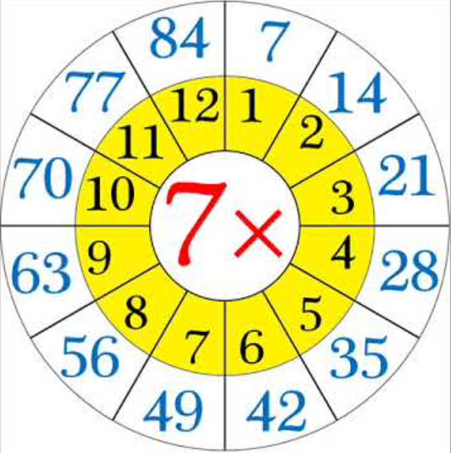

7) Rhymes - Use Rhymes to aid the Memory. I ate and ate ‘til I was sick on the floor: 8 times 8 is 64! Wakey, wakey, rise and shine: seven 7s are 49!
YouTube has an endless supply of times tables songs.

8) Quick questions anywhere - Fire questions at your child anywhere and everywhere! Take them by surprise and see how quickly they can respond!

How is my child doing?
The heat map on TT Rock Stars is a fantastic way to monitor your child’s progress and identify the multiplication facts they need more practice with. To view your child’s heat map, login using your child’s TT Rock Stars details, click on your child’s avatar on the top right of the screen. Select ‘My Stats’ and the heat map will appear.
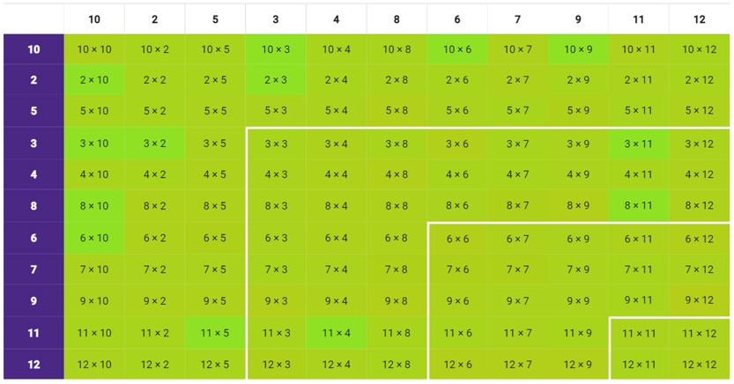
When children have a secure knowledge of all multiplication facts up to 12x12, their heat map will look like this:

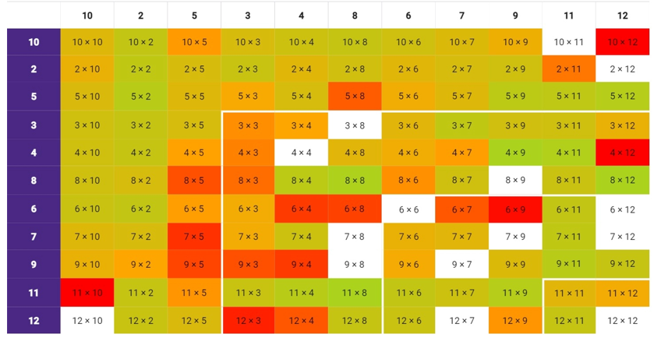
The colour indicates how many seconds your child takes to recall that fact. White or grey boxes can indicate that your child has not played enough TT Rock Stars to generate data on those questions. They will begin to change colour as they appear in practice games.

Focusing on the darker or blank boxes will help close the gaps in your child’s times table knowledge. You can also identify whole tables they are not secure on.
Key Vocabulary
Here are some words that may be used whilst learning and applying multiplication and division.

multiply | divide | lots of | repeated addition | times | double | halve | square number
prime | product | factors | array | repeated subtraction | multiple | sets of | remainder

Factor - One number is a factor of another if it divides or ‘goes into’ it exactly (without any left over, a remainder). E.g. 6 is a factor of 30 because it goes into it 5 times, but is not a factor of 33 because after dividing, there is a remainder of 3.

Groups of/ lots of/ sets of – 3 groups of 5 are 15, 3 lots of 5 are 15, 3 sets of 5 are 15 (3 x 5 = 15).

Multiple - These are the numbers that you find in a times table. E.g. 20 is a multiple of 5, 4, 2 and 10 because it is found in all of those times tables. The multiples of 5 are 5, 10, 15, 20 etc.

Product - A product is the answer you get when you multiply two or more numbers together. E.g. the product of 3 and 4 is 12 (3 x 4 = 12).

Prime - A prime number will only divide equally between 1 and itself e.g. 7, 11. The first ten prime numbers are: 2,3,5,7,11,13,17,19,23,29.
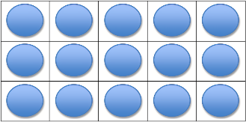
Array - An array is a visual representation of multiplication. Shown are 3 rows of 5 with 15 in total.

Square number - The product of multiplying a whole number by itself, for example: 4 × 4 = 16, 16 is a square number.

