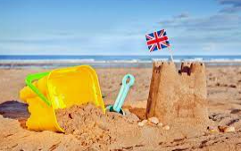
Beside the Seaside!
Summer B Learning Challenges
Have you been to the beach? Talk with your family about what you did when you were by the sea. What did you see? What did you smell? If you have some photographs of visits to the seaside, have a look at them whilst you are talking.
Look at the ice cream menu on the school website and work out how much the adults in school had to pay for their ice creams! Remember to use a number line or counting toys to help you with your problem solving.  Extra challenge: Order your own ice cream and work out the price. Record it using the cards on the final page of the resource. | Imagine you have just got home from a day at the seaside. Write a postcard telling a friend what you did. There is a postcard template on the school website or you can draw your own.  Extra challenge: Find out the school address and post your work to your teacher.
Choose a photograph of a time that you visited the seaside. Write about what you were doing in the photograph. Try to record 2 or 3 sentences.  Extra challenge: Add another sentence that tells the reader how you were feeling at the seaside. There is an emotions word mat on the school website. | Create an iced treat! Follow the instructions on the school website.  Extra challenge: Draw a picture of your ice lolly, give it a name and write a list of the ingredients. Share it with school so we can try out your recipes.

Useful links to look at with an adult.
Please be mindful of e-safety, particularly with Youtube links.

About the seaside:
https://www.bbc.co.uk/iplayer/episode/b09vk2cf/my-first-series-2-2-trip-to-the-seaside
https://www.bbc.co.uk/cbeebies/radio/shhh-listen-seaside

