Who was Etheldreda?

Etheldreda was the foundress and abbess of Ely.

She was the daughter of Anna, king of East Anglia, and was born, probably at Exning, near Newmarket in Suffolk.
At an early age, she was married, in about the year 652, to Tondberht, ealdorman of the South Gyrwas. On his death, in about 655, she retired to the Isle of Ely, to the place she had been given in her dowry (a gift that was given to a woman as part of her wedding agreement).

In 660, for political reasons, she was married to Egfrith, the young king of Northumbria who was then only 15 years old, and several years younger than her. Twelve years later, Etheldreda left Egfrith and became a nun at Coldingham which was run by her aunt Ebbe (672). She then founded a double monastery at Ely in 673.

Etheldreda restored an old church at Ely, reputedly destroyed by Penda, pagan king of the Mercians, and built her monastery on the site of what is now Ely Cathedral. Etheldreda's monastery flourished for 200 years until it was destroyed by the Danes. It was refounded as a Benedictine community in 970. After its restoration in 970 by Ethelwold, it became the richest abbey in England except for Glastonbury.

It is thought that Etheldreda died in about 680 as a result of the plague which also killed several of her nuns, many of whom were her sisters or nieces. Seventeen years after her death, she gained a reputation as a remarkable and saintly woman because, when Wilfred and her physician Cynefrid looked at her remains, they her to be incorrupt: a wound on her neck, cut by her doctor, was found to be healed. The linen cloths in which her body was wrapped were as fresh as the day she had been buried. Her body was placed in a stone sarcophagus of Roman origin, found at Grantchester and reburied.
For centuries, Etheldreda's shrine was the focus for vast numbers of medieval pilgrims. It was destroyed in 1541, but a slate in the Cathedral marks the spot where it stood. The 23rd of June and 17th of October are still kept as major festivals in the Cathedral.
(Taken from Ely Cathedral website)
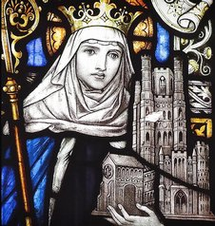
When was the present Cathedral built?
Work on the present Cathedral began in the 11th century under the leadership of Abbot Simeon, and the monastic church became a cathedral in 1109 with the Diocese of Ely (the area belonging to the church) taken out of the lands of the Diocese of Lincoln. The monastery was very successful and rich for many years.
Which parts of the old monastery are still present in the Cathedral site today?
The oldest standing buildings are the prior's house with its vaulted under-croft (high ceilinged cellar), and the central part of the infirmary (hospital) complex, both built in the 12th century. The infirmary was a long rectangular building with a high roof over its central hall and an aisle on either side. The hall has lost its roof and is now a road called Firmary Lane.
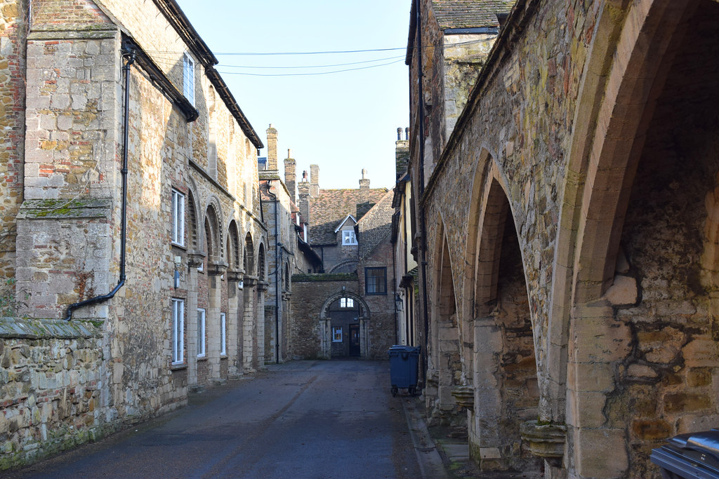
Here, the blocked arches which led from the central hall into the side aisles can be seen. At the east end of the lane, a stone wall with a 12th century door separated the hall from the infirmary chapel, which has also now lost its roof. At the end of the lane the sanctuary of the chapel stands within the 19th century brick building which forms part of the Chapter House.
By the end of the 13th century the cathedral and its monastic buildings were largely complete, and included the Almonry of the east side of the north range, the Great Guest Hall for lay visitors and the Black Hostelry for visiting Benedictine monks.
Major works began again in 1321, with the start of the building of the Lady Chapel. In 1322, the central tower of the cathedral collapsed and this event led to lots of new building as the tower had to be replaced.
During the next 30 years, The Octagon was built, the Lady Chapel was finished, and some of the monastic buildings were substantially altered: it was a remarkable and expensive programme. Prior Crauden's Chapel was finished in 1324, and the Queen's Hall in the 1330's. At the same time the Sacrist's Office was built by the Sacrist Alan of Walsingham, who was responsible for the organising of the building work.

In the Old infirmary, the north aisle was demolished and replaced by a large L-shaped house, Powcher's Hall (named after Prior William Powcher), and Alan of Walsingham's building. Most of the other surviving buildings show some signs of extension of remodeling during this period, after which there was a clear pause in activity.

Towards the end of the 14th century there were changes made at the southern end of the site, next to the old 11th century castle mound. A monastic barn was built to store the Abbey crops, next to a new gatehouse, the Porta. Both probably replaced earlier buildings with the same purpose.

The monastery at Ely was dissolved by King Henry VIII in 1539. This was at a time when Henry became the Head of the English church and he ordered that many church buildings, which had belonged to the Pope in Rome, be closed down and all the wealth and possessions taken into the King’s treasury. Ely suffered less than many other monasteries at this time, but even so, statues were destroyed together with carvings and stained glass. St Etheldreda's Shrine was destroyed.

Even though the monastery was closed, the bishopric remained, and the bishop continued to live in the medieval Bishop's Palace (now part of King's Ely) until the early 20th century. The Cathedral was refounded with a Chapter of eight canons in 1541. Robert Steward, the last Prior of the monastery, became the first Dean. Much of the old monastery buildings were destroyed but old the Infirmary (hospital) buildings, which already contained several separate 14th century houses, were adapted for the priests who worked in the cathedral. The Dean, successor to the Prior and head of the new establishment, took over some of the guest halls and prior's buildings, and so these still survive.

The first major restoration took place in the 18th Century under James Essex.
With the arrival of Dean George Peacock in 1839, a second restoration project began. Together with the architect Sir George Gilbert Scott, he restored the building to its former glory.
A third major restoration project, the most extensive to date, was begun in 1986 and was completed in the year 2000.

