Hunts School Sports Partnership
30 Day Physical Activity Challenge

Day 1 – Build an Obstacle Course

Create an obstacle course around your home or if you have one, your garden. Here are some ideas for your different stations:
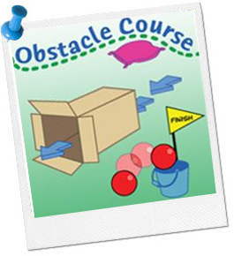
- Throw and catch a ball or object 10 times before moving on
- Step ups on a bottom step of stairs or sturdy step in the garden
- Use pebbles or objects like soft toys to slalom around
- Go over or under pieces of furniture (as long as it’s safe to do so!)
- Complete other exercises such as star jumps, squats, lunges, press ups before moving on
- If you’re lucky enough to have play equipment in your garden, use some of that!

Make sure it’s a safe course by checking for hazards before you complete it. Make it a challenge by timing it. Can you beat your adult’s time?

Hunts School Sports Partnership
30 Day Physical Activity Challenge

Day 2 – Follow a Trail

Make and complete a set of control cards and a map for this trail activity around your home

- Create around 10 control cards. Put a number on one side and then ask an adult to write a question or maybe a maths calculation on the other.
- Draw a map of your ‘playing area’ – this could be inside the house or in the garden.
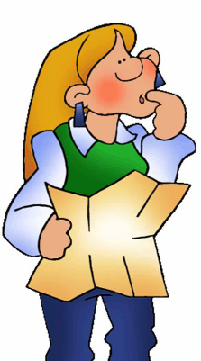
- Ask your adult to place the cards around the area and mark on the map the number card locations.
- Follow the trail making sure you start with card 1.
- You could make an answer grid to record your answers.
- Maybe your answers could lead to some form of treasure or treat!
- Can you complete your trail and answer the questions?
Make your own cards for someone else in your household. You can make it more difficult or easy by changing the challenge of the questions and where you choose to place your control points!

Hunts School Sports Partnership
30 Day Physical Activity Challenge

Day 3 – Leaf Bingo!

Time to get active, get outdoors and go exploring! This activity involves identifying examples of different plant and tree leaves. Use the reference sheet to identify and group these leaves depending on their physical characteristics.

- Give yourself a time to find as many different leaves as possible!
- You will need a pen or pencil, paper and the leaf bingo sheet.
- Remember to respect the plants / trees and always ask permission if you are going to pick any!

Hunts School Sports Partnership
30 Day Physical Activity Challenge

Day 4 – Material Scavenger Hunt

Time for some active science! In this material scavenger hunt you will collect, identify and name a variety of everyday materials, including wood, plastic, glass, metal, water, and rock.

- You will need to move around the house and or garden and find a variety of different objects.
- You will then need to categorise then according to their properties.
- For example, are they hard, soft, stiff, stretchy, shiny or dull?
- All properties can be found on the example sheets.
- Can you turn it into a race? How long does it take you to collect an item for every property? Who can find an item for every property the quickest?
- You will need a pen or pencil, list of material properties and your imagination
Hunts School Sports Partnership
30 Day Physical Activity Challenge

Day 5 – Symbols Relay

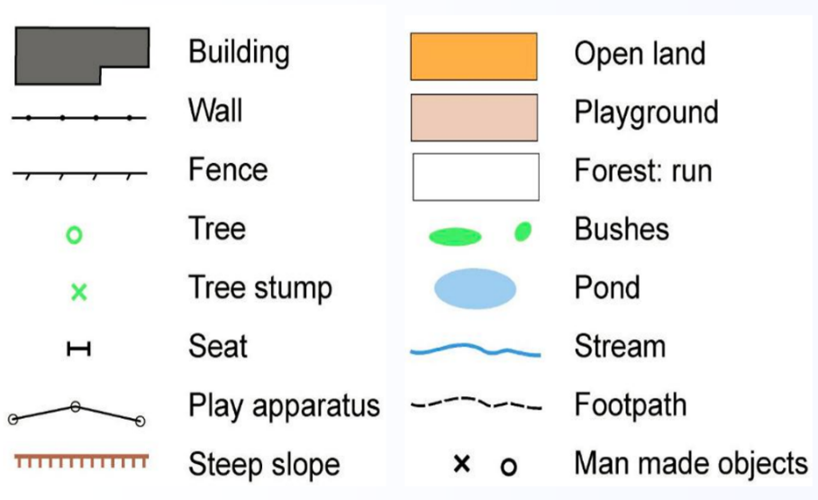
We love some of the Outdoor Adventurous Activities from www.britishorienteering.org.uk/ and use them a lot in our teaching. This is an adapted version of one of these, to be played inside or outside. You could play on your own or with someone else in your household.

- Create two sets of cards, around 16-20 in each set
- On one set, write the words of locations on maps
- For example, pond, tree, building, footpath etc
- On the other set, draw a symbol to go with the word
- Use the ideas in the picture here
- Place all the word cards at one end of your playing area
- Place all the symbol cards at the other end, make them as far away as possible
- Pick a word card, run to the symbols and try to find correct match before taking it back
- To make it harder, make it a memory Pairs Game – only turn one symbol card over before returning back ‘home’ before having another go

