Outdoor Learning-Step into summer 3

Micro-Habitats  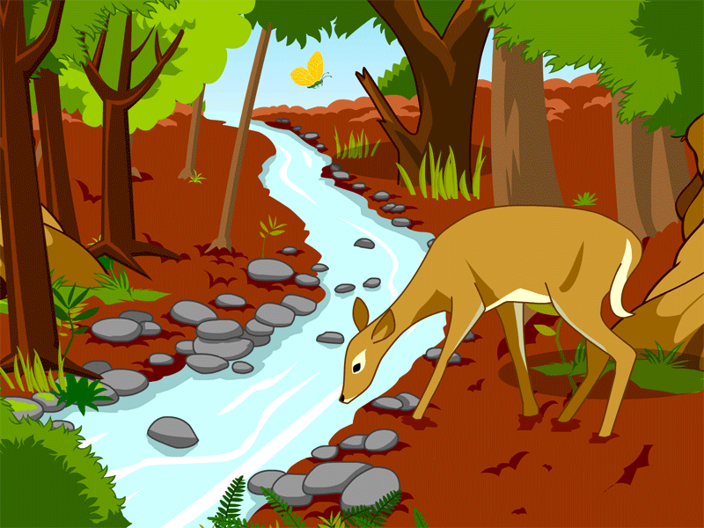  Small animals such as insects may be found under logs. Some are so tiny they can hardly be seen, except with a magnifying glass or microscope.  Find a dead log (or plant pot!) and roll it over. Draw or write about any animals or plants you see. Don’t forget to roll the log back. (You might want to take a magnifying glass with you, if you have one)  Challenge: At home, find out about each animal or plant. | Living, dead or never alive  Wherever you are over the next three weeks, write down or draw all the things you can see that are...  a. living  b. were living, but are now dead  c. have never been alive  Sort them into groups. Which has the most things in it.  Top tip: Living things eat, drink, move about, breath, touch  Things that were alive but are now dead might include wilted flowers, an old log, a dead woodlouse  Things that have never been alive won’t grow, drink water, or need to breathe  Challenge: Create a quiz for a family member. Can they sort your items under the correct headings? | Grouping by properties  Look for five objects outside. Draw them. Write the material(s) they are made of and write two properties for each.  Examples of properties: soft, hard, bendy, heavy  Challenge: Name three things that are the opposite of heavy.  Use three words to describe the properties of a rock.
Fairy pit stop  Walking round school last week, lots of children were telling me they had lost teeth. I began to feel very sorry for the poor Tooth Fairy and imagined that she was exhausted from all the toing and froing each night. To stop this happening, could you design and build a fairy pit stop for the tooth fairy. The materials you choose will have to be waterproof, the design will have to be sturdy so it doesn’t blow away. You must include comfortable furniture for her and make the place nice and cosy. Lots of things to take into account. To help you make some important decisions, you could first test some of the materials before you start building.  Challenge: Can you include some wall art in your pit stop? | Nature Shapes Scavenger Hunt  They say there are no straight lines in nature. How many of these shapes can you find? You might not see them all, so don’t worry!  - Circle  - Cone  - Corkscrew  - Horseshoe  - Jagged edge  - Oval  - Rectangle  - Sharp point  - Sphere  - Spiral  - Square  - Teardrop  - Triangle  - Wavy line  - Straight line  - zigzag | Pet rocks  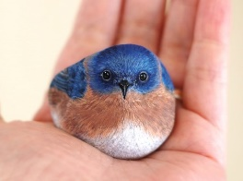  What you will need:  - a variety of rocks  - different coloured paints/pens  Do you fancy a pet that you never have to feed or pick up its poo?  If you do, then have a go at making a rock pet. First of all, decide what kind of pet you would like. Be creative! It might even be a dinosaur! Choose a nice smooth rock and paint. Remember to leave time to dry between layers and always apply the lightest colours first and add the detail later. You could print a picture of your pet beforehand so you have a very clear picture in your mind of what you are trying to create.

